T

Hawk Channel Design

Product Suite | TIBCO BusinessEvents
Product | TIBCO BusinessEvents
Product Version | 5.1
Initial Author | Shivkumar Chelwa

Copyright Notice
COPYRIGHT© 2008-2009 TIBCO Software Inc. This document is unpublished and the foregoing notice is affixed to protect TIBCO Software Inc. in the event of inadvertent publication. All rights reserved. No part of this document may be reproduced in any form, including photocopying or transmission electronically to any computer, without prior written consent of TIBCO Software Inc. The information contained in this document is confidential and proprietary to TIBCO Software Inc. and may not be used or disclosed except as expressly authorized in writing by TIBCO Software Inc. Copyright protection includes material generated from our software programs displayed on the screen, such as icons, screen displays, and the like.
Trademarks
Technologies described herein are either covered by existing patents or patent applications are in progress. All brand and product names are trademarks or registered trademarks of their respective holders and are hereby acknowledged.
Confidentiality
The information in this document is subject to change without notice. This document contains information that is confidential and proprietary to TIBCO Software Inc. and may not be copied, published, or disclosed to others, or used for any purposes other than review, without written authorization of an officer of TIBCO Software Inc. Submission of this document does not represent a commitment to implement any portion of this specification in the products of the submitters.
Content Warranty
The information in this document is subject to change without notice. THIS DOCUMENT IS PROVIDED "AS IS" AND TIBCO MAKES NO WARRANTY, EXPRESS, IMPLIED, OR STATUTORY, INCLUDING BUT NOT LIMITED TO ALL WARRANTIES OF MERCHANTABILITY OR FITNESS FOR A PARTICULAR PURPOSE. TIBCO Software Inc. shall not be liable for errors contained herein or for incidental or consequential damages in connection with the furnishing, performance or use of this material.
For more information, please contact:
TIBCO Software Inc.
3303 Hillview Avenue
Palo Alto, CA 94304
USA
Table of Contents
Change Log 4
Related Documents 4
1 Introduction 5
Purpose 5
Scope 5
Audience 5
References 5
2 Acronyms and Vocabulary 6
3 Hawk Events & Alerts 7
Hawk Catalog Functions 7
4 Hawk Method Invocation 10
5 Hawk Method Subscription 10
6 Designtime Config(Hawk Channel/Destination) 12
7 Runtime (Channel Initialization) 13
8 Exception Handling 13
Appendice A: 14
Appendice B: 15

Change Log
.
Date | Version | Name | Description
03/10/11 | 0.1 | Shivkumar Chelwa | Initial Document Creation

Related Documents
Document Title | Revision Number | Author
User Guide | 5.1 | Jackie Pascoe

Introduction

Purpose
The purpose of this document is to discuss design of Hawk Channel to enable receiving alerts & events, invoking hawk methods and method subscriptions in BusinessEvents project.

Scope
This scope of this document is restricted to listening events and alerts from hawk domains. Also, this document discusses method invocation and subscription. The hawk channel for BusinessEvents does not help users in deploying and managing hawk rules on any other hawk administrative activities.

Audience
- Developers
- Architects
- Quality Assurance

References

Acronyms and Vocabulary

The table below describes some of the Acronyms used in this documentation
- BE – TIBCO BusinessEvents.
- EAR - Enterprise Archive
- SAR - Shared Resource Archive
- BAR – BusinessEvents Archive
- Cluster
- Agent
- Deployment
- CDD – Cluster Deployment Descriptor

Hawk Events & Alerts

The TIBCO Hawk product provides access to various events and alerts emerging in hawk domain via TIBHawkConsole API. The hawk channel for BusinessEvents uses the TIBHawkConsole API to listen to events like AgentMonitorEvent, RuleBaseListMonitorEvent, AlertMonitor, Errors and Warnings.
The events & alerts in hawk are modeled in BusinessEvents as Events and Concepts. The TIBCO BusinessEvents 5.1 will ship a project library containing a set of pre-defined events and concepts corresponding to all possible events & alerts in TIBCO Hawk. The user of Hawk Channel will have to import this project library. When an event/alert is received via TIBHawkConsole, based on the channel destination configuration, the event/alert is deserialized into one of the events. This event is asserted into working memory of rete engine which will trigger a RTC.
Figure 1 display the list of events in the project library.
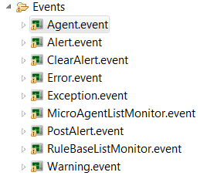
Figure 1

A event deserialized by hawk destination will have an Object payload. The object will be event source i.e. instance of AgentInstance class.

Hawk Catalog Functions
A set of catalog functions will provided to access information from object payload i.e. AgentInstance instance as required. The catalog function will be available under Hawk function catalog and they can be used in rule condition as well as action.
Figure 1 displays the catalog functions to access information related to agent instance.

Figure 2
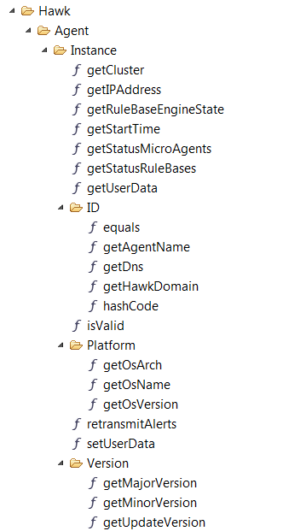

Figure 3 displays the catalog functions to access information related to agent’s microagents.
Figure 3
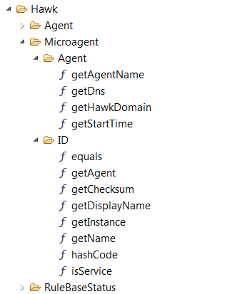

Figure 4 displays the catalog functions to access information related to agent’s rulebases.

Figure 4
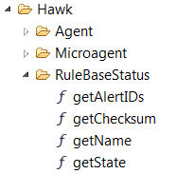

Hawk Method Invocation

A set of catalog functions will be provided to invoke Hawk methods from BusinessEvents. The return values of method invocation can be handled using another set of catalog functions OR a event/concept URI can be passed so that the return values is mapped to event/concept properties and a instance is returned.
The initial investigation of API indicated that the method parameter names have to be exact while method invocation. The catalog function to invoke methods takes following parameters.

1. string array for parameter names
2. a

b. An object array for values
Issues
i. What if input is of type composite/tabular?
Handing Return Value
1. Method Invocation
a. Return objects as it is. We will provide a set of catalog functions to handle composite and tabular data e.g. getNames():String[] and getValues(String):Object. And primitive can be converted to BE supported data type on the fly.
b. We can take an entity uri as input and serialize the return values to event/concept in case of composite data and array of event/concept in case of tabular data and an object as it is in case of primitive. User may choose to assert event and concepts are asserted by default.
c. Exception handling at runtime, if data types does not match

Hawk Method Subscription
Only open method should be subscribed. Only the methods that return data should be subscribed meaning methods of type IMPACT_INFO and IMPACT_INFO_ACTION.
The input parameters to subscription methods must be constants/global variables when subscription is made at designtime using a import util. If subscription is done using catalog function then parameters can be variables
c. Issues
i. What if input is of type composite/tabular

Handing Return Value
a. A rule function or custom catalog function to handle data. The handler may choose to create an event/concept and assert. We will provide a set of catalog functions to handle composite and tabular data e.g. getNames():String[] and getValues(String):Object.
b. Serialize to an Event and assert. Ask for the event type at the time of subscription.
c. Issues:
i. What to do if the subscription returns a primitive type.
1. a function that handles the return value
2. a event having only one property of this type

Designtime Config(Hawk Channel/Destination)

A new channel type will be added to the existing list of channel types in BusinessEvent Studio. Figure 5-9 shows the sample screens of Hawk Channel. The driver name will be “Hawk”
The channel configuration gives an option to choose the underlying transport for the Hawk domain. A drop down let users choose either RV (TIBCO Rendezvous) or AS (TIBCO Active Spaces) as transport options. If RV transport is chosen then method of configuration could be Properties or Resource. Where as AS transport can be configured using properties only (as BusinessEvents Studio 5.1 does not have a AS shared resource).
A channel destination must be added to complete the channel configuration. A destination will have a name, description and event type. The event type will be either “Hawk Event” or “Method Subscription”. If “Hawk Event” is chosen then one of the serializer have to be select to decide which type of hawk events should be listened to. If “Method Subscription” is selected then users will have to click on “Add Configuration” which lets users select from the various Hawk Agents and Micro agents the methods to be subscribed. The arguments to the method subscription could be constant or a global variable.
Figure 5

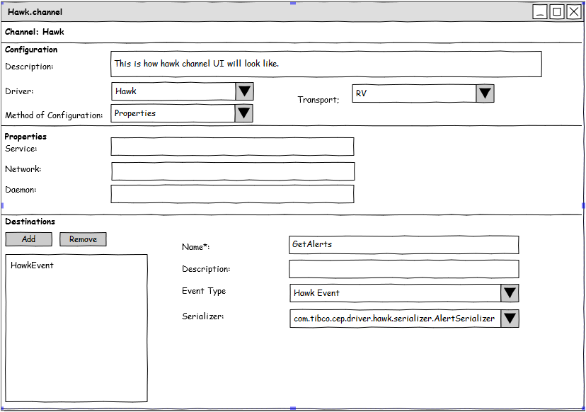

Figure 6
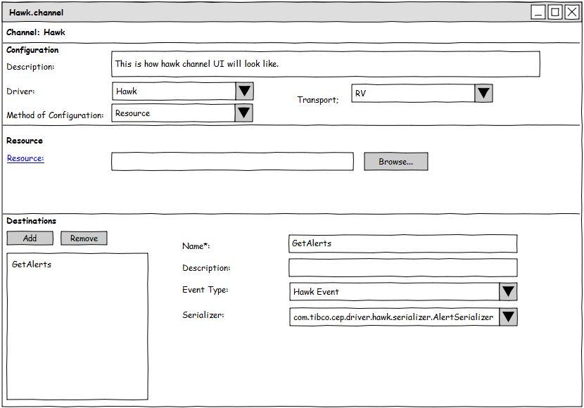
Figure 7
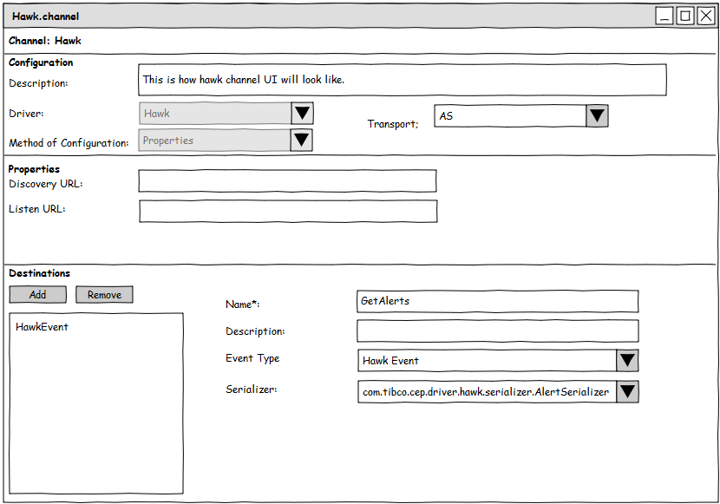
Figure 8
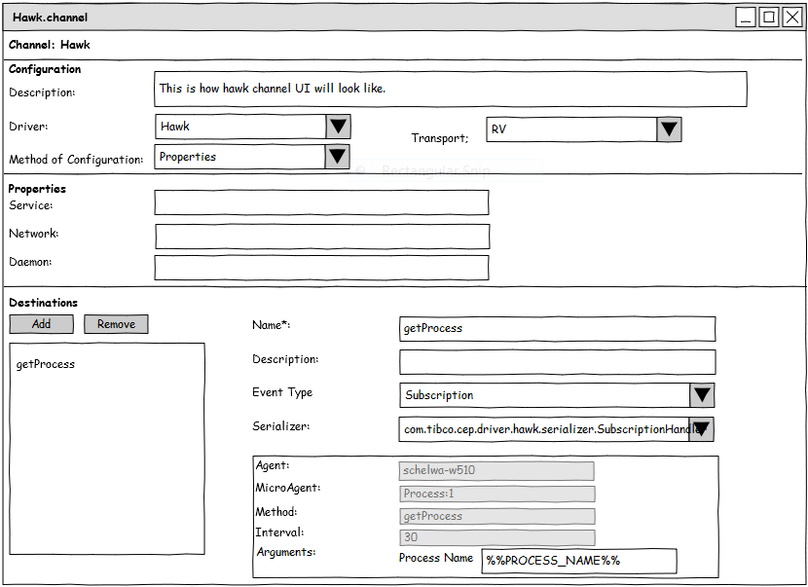

Figure 9
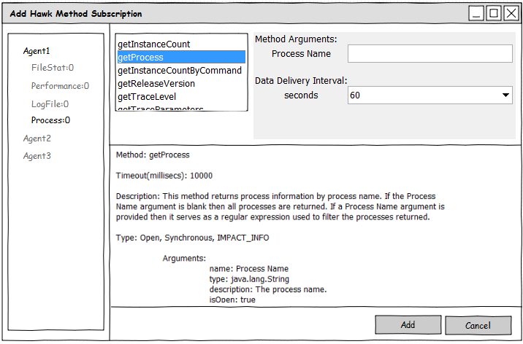

Runtime (Channel Initialization)
When the BusinessEvents engine is started the hawk channel is initialized with the channel configuration. The runtime creates a instance of TIBHawkConsole for each channel instance. This way multiple Hawk domain can be integrated with BusinessEvents.

Exception Handling
The following exception scenario has to be handled.
- A hawk domain is not accessible at runtime.
- The microagent corresponding to a method subscription (destination) is not up.
- The microagent corresponding to a method subscription (destination) has gone down.
- The rule invoking a hawk method and the microagent of the methods is down.

Appendice A:

Appendice B:

